**Error**

* There are two types of errors occurs in programming language.
* Compile Time Error
  + The error which occurs during the compilation phase of the program is called compile time error.
* Run Time Error
  + The error which occurs during the execution phase of the program is called run time error.
  + Run time error is also known as Exception.

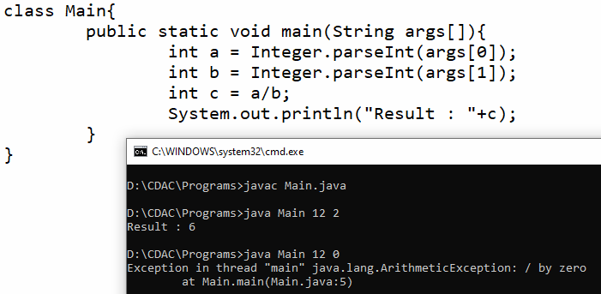

**Exception Handling**

* Exception handling is a mechanism to handle run time error.
* The main objective of exception handling is used ***to prevent abnormal program termination***.

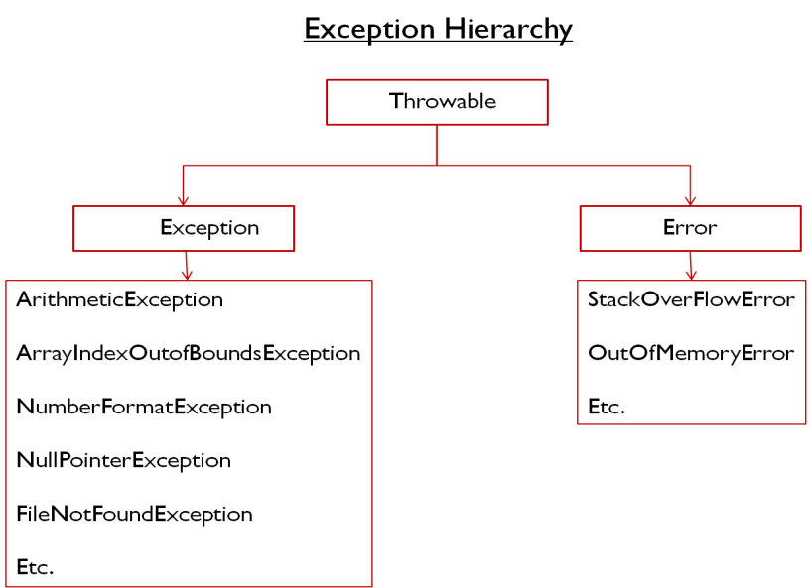

**Exception handling key words**

* try
* catch
* finally
* throw
* throws

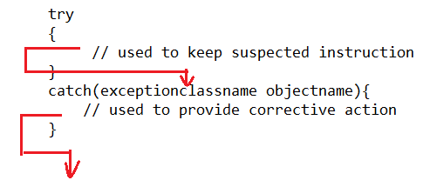

**Example#1**

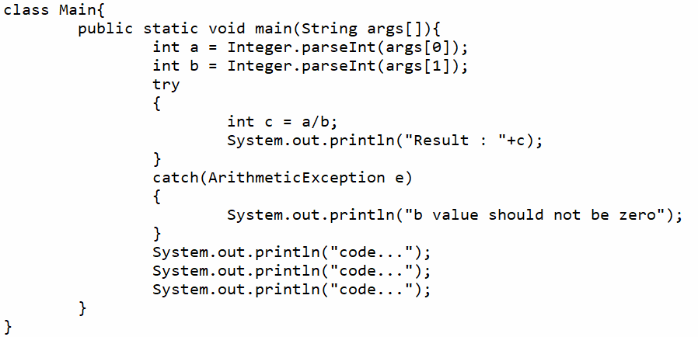

**Multiple Catch Bock**

**Example#2**

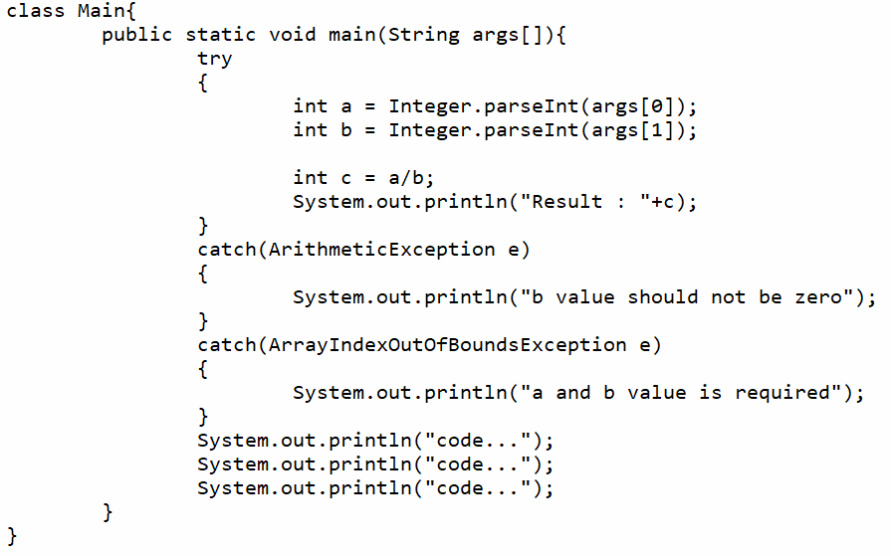

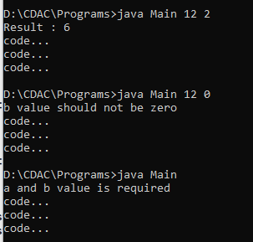

**Generic Exception**

**Example#3**

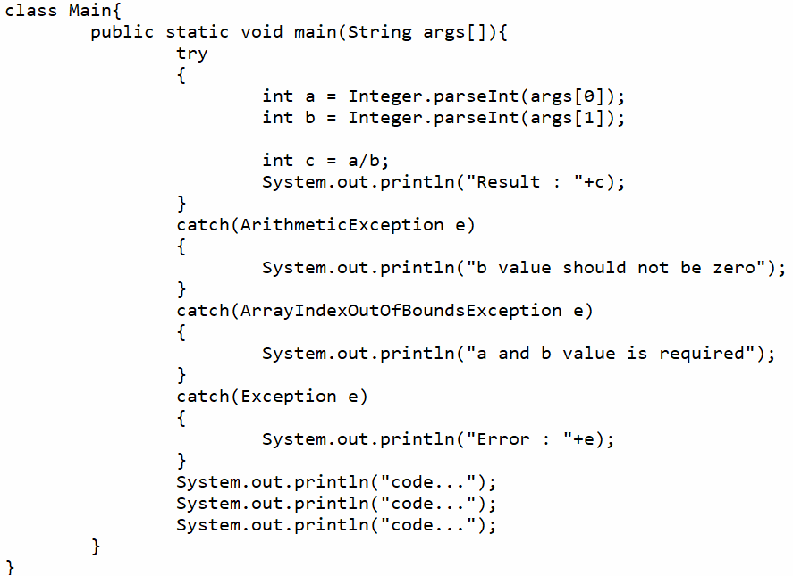

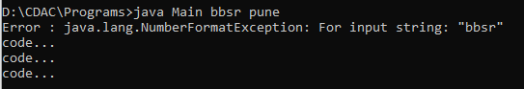

**Finally**

* Finally block is always executed whether exception is raised or not.
* It is used to provide clean up code
  + Database connection closing
  + Object destruction
  + File Closing
  + Etc.

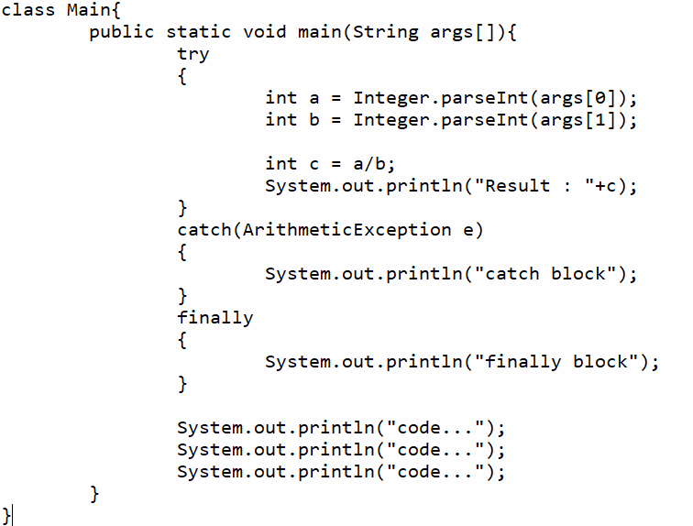

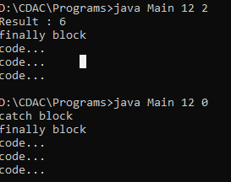

**Note**

* In the exception handling must handle the exception in two ways
  + By using try catch blocks
  + By using throws keyword

**Throws**

* throws keyword is bypassing the exception from present method to caller method.
* If main method is throws the exception then JVM is responsible to handle the exception.

**Checked Exception vs. Unchecked Exception**

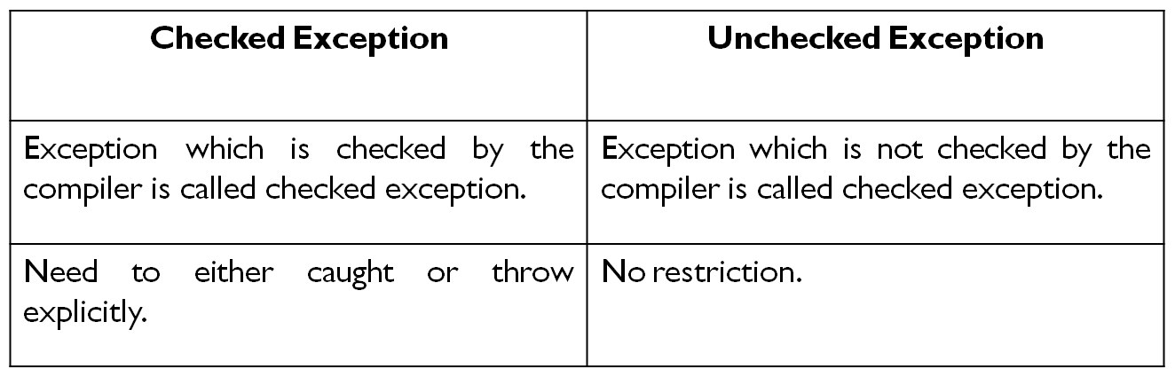

**Unchecked Exception**

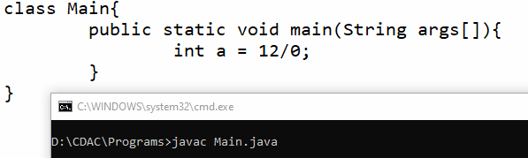

**Checked Exception**

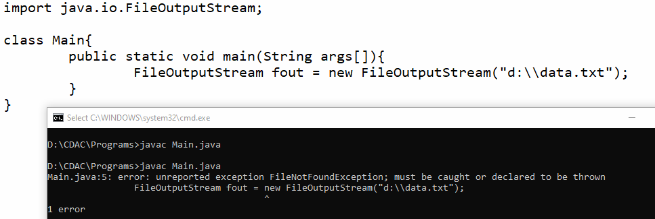

**Example# (throws)**

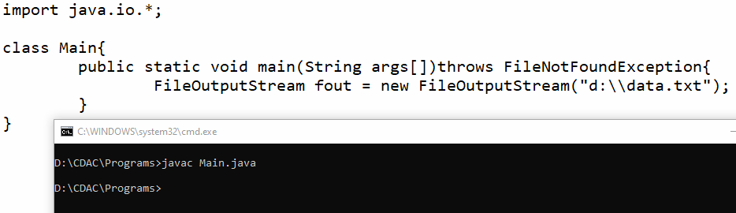

**Throw**

* Throw is used to throw predefined or user defined exception explicitly.

**Difference between throw and throws**

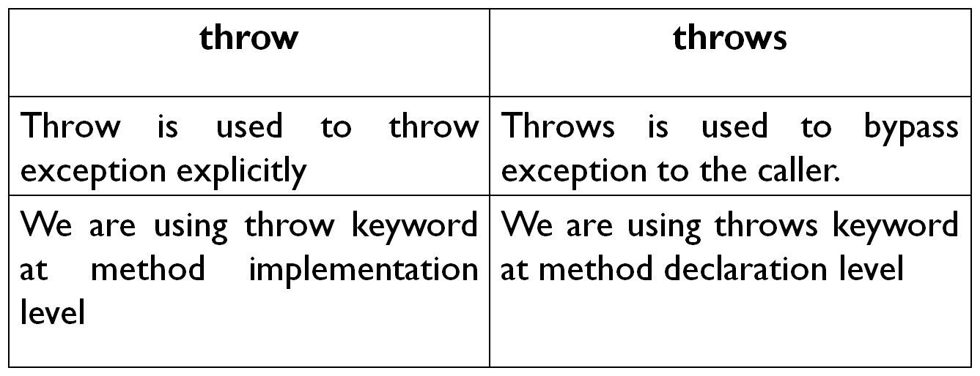

**StackOverFlowError**

class Main

{

static void display()

{

System.out.println("display...");

display();

}

public static void main(String args[])

{

display();

}

}

**OutOfMemoryError**

class Main

{

public static void main(String args[])

{

int arr[] = new int[1000000000];

}

}

**User defined exception**

Exceptions created by user are called user defined Exceptions.

class MyException extends Exception

{

MyException(String msg)

{

super(msg);

}

}

class Main

{

public static void main(String args[])

{

try

{

int age = Integer.parseInt(args[0]);

if(age<18)

{

throw new MyException("You are not eligible for voting");

}

System.out.println("You are eligible for voting");

}

catch(Exception e)

{

System.out.println(e.getMessage());

}

}

}

**Try with resource**

import java.io.*;

class Main

{

public static void main(String args[])

{

try(FileOutputStream fout =new FileOutputStream("data.txt")) {

fout.write("BBSR1".getBytes());

System.out.println("Date Saved..");

}

catch(Exception e)

{

System.out.println(e);

}

}

}

**User Defined Exception / Custom Exception**